Data Model Refactor Plan — My Cocktail Collection
Nov 6, 2026 · @Bill

Summary
Rebuild the data layer on SwiftData with a proper Family → Style → Bottle taxonomy, real relationships and structured ingredients, and move existing data across with a one-time import that leaves the current database untouched as a backup.
- Spirits become a two-level taxonomy. 13 fixed families (Whiskey, Gin, Agave, Liqueurs & Amari, Mixers & Syrups…) with editable styles underneath (Bourbon, Rye, London Dry, Aperitivo…). The old Liquor/Liqueur "type" goes away.
- Every link is a relationship. Cocktails point to their base style, bottles to their style, menus to their entries, with delete rules that clean up after themselves. No more UUID lookups or orphaned menu items.
- Ingredients become rows (amount in parts, name, optional link to a style), parsed from today's text, with the original text kept and a review flag where parsing was unsure.
- The model is iCloud-ready, so sharing the collection between two phones is a later switch, not another refactor.
- Seven phases, each a reviewable commit on a data-model-refactor branch, with tests guarding the migration before any screen changes.

Goals and non-goals
Goals
- Find cocktails by precise style (Bourbon) or broad family (Whiskey).
- Organise the bottle collection by family and style, including wine, beer, cider, mixers, vermouth and bitters.
- Store ingredients as structured rows so later features can match recipes against the shelf.
- Replace UUID lookups with relationships and delete rules, so nothing is left orphaned.
- Keep every existing recipe, rating, photo, favorite, bottle and menu. Nothing is lost or retyped.
- Design for iCloud sync between two phones from the start.
Not in this refactor
- Turning on iCloud sync itself (the model is ready; switching it on is its own step).
- "What can we make tonight?" and a shopping list for a menu. The structured data enables them; the screens come after.
- Tracking fresh ingredients (citrus, mint, eggs) as stock.

Problems with the current model
The current Core Data model (version 3) works, but five design choices block the features you want next.
Problem | Where it shows up | Fix in the new model
A drink's base spirit is a stored UUID, not a relationship | Manual lookups in every screen; deleting a spirit leaves drinks pointing at nothing | Cocktail.baseStyle relationship
One flat "spirit" list mixes categories, broad types and a brand | "Liqueur" is both a type and a category; Aperol is a category; Liquor is too broad | Family (fixed) → Style (editable)
Menu items have no inverse relationships | Orphaned "Deleted Cocktail" rows; deletes need hand-written cleanup | Menu.entries and Cocktail.menuEntries with cascade rules
Ingredients are one block of text | No search by ingredient, no matching against the shelf, no scaling | RecipeIngredient rows
Every attribute is optional and untyped | drinkName ?? "" everywhere; source and stock stored as raw numbers | Non-optional names, enums for source, family, unit and stock

Approach: SwiftData with a one-time import
Decision: build the new model in SwiftData in a new database file, and copy the existing data into it once, on first launch of the new version. The current Core Data file is left untouched as a backup.
 | SwiftData + one-time import (chosen) | Core Data version 4 + custom migration
Model code | Plain Swift classes with @Model; relationships in one line | Model editor + generated classes; optionals everywhere
Screens | @Query replaces @FetchRequest in each list | Screens stay on @FetchRequest
Migration | Read old file, write new file; easy to test and re-run | Lightweight step plus hand-written fix-up code in the same file
If something goes wrong | Old file still there; delete the new one and import again | Data already changed in place; needs a device backup
iCloud later | Built in: a container option | Possible, more setup
Effort | Larger (every screen's fetches change) | Smaller now, but leaves the next step (SwiftData) still to do
The app already requires iOS 17.2, so SwiftData is available with no change to who can install it.
iCloud-ready rules (so syncing is a later switch): every attribute has a default value or is optional, every relationship is optional, no unique constraints, and photos use external storage. Uniqueness (one style per name, for example) is enforced in code instead.

Spirit taxonomy
Thirteen families are fixed in code; styles are records you can add to, each belonging to one family. Cocktails and bottles link to a style, so a Manhattan is a Rye cocktail and, through Rye, a Whiskey cocktail.
Family | Built-in styles | Example bottles
Whiskey | Bourbon, Rye, Scotch, Irish, Japanese | Buffalo Trace, Lagavulin 16
Gin | London Dry, Old Tom, Contemporary | Tanqueray, Hendrick's
Rum | Rum (general), White, Aged, Dark, Agricole | Plantation 3 Stars
Agave | Tequila Blanco, Tequila Reposado, Tequila Añejo, Mezcal | Espolòn Blanco, Del Maguey Vida
Brandy | Brandy (general), Cognac, Armagnac, Pisco, Calvados | Pierre Ferrand 1840
Vodka | Vodka, Flavored Vodka | Tito's
Liqueurs & Amari | Orange, Coffee, Herbal, Aperitivo, Amaro, Cream, Fruit & Nut | Cointreau, Campari, Aperol, Green Chartreuse
Vermouth & Fortified | Sweet Vermouth, Dry Vermouth, Sherry, Port | Carpano Antica, Dolin Dry
Bitters | Aromatic, Orange, Other | Angostura, Peychaud's
Wine | Red, White, Rosé, Sparkling, Dessert | Champagne, Prosecco
Beer & Cider | Lager, Pale Ale & IPA, Stout & Porter, Wheat, Sour, Cider | Modelo Especial, Angry Orchard
Mixers & Syrups | Tonic & Soda, Ginger Beer & Ale, Bottled Juice, Syrups, Cream of Coconut | Fever-Tree Tonic, Topo Chico, Orgeat
Other | Aquavit, Absinthe, Sake
- Family is an enum with a display name, an SF Symbol and a sort order. Fixed, so filters, seed data and grouping stay consistent.
- Style has a name, its family, and whether it's built-in. You can rename, add or delete styles; built-ins deleted stay deleted, the same rule as today's seeding.
- Brands live only on bottles. Aperol is a bottle in Liqueurs & Amari → Aperitivo, and the Aperol Spritz's base style is Aperitivo.
General styles. Rum and Brandy cocktails use the general Rum and Brandy styles, because recipes already name the specific rum or brandy in their ingredients. The specific styles (Aged rum, Cognac) are there for bottles, and for any recipe you want to pin down.

New data model
Six models replace today's five entities. Every link is a relationship with an inverse, and the delete rules do the cleanup that screens do by hand today.
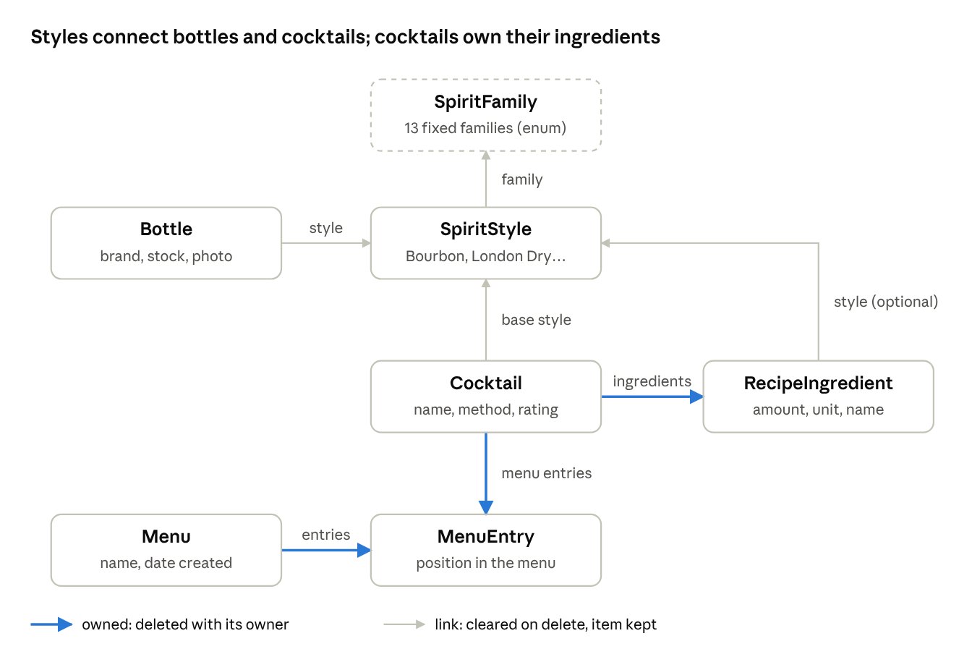
new data model · 6 models, 1 enum
Arrows point from an item to what it links to. Highlighted links are owned: deleting a cocktail removes its ingredients and menu entries, and deleting a menu removes its entries.
Model | Fields | Relationships (on delete)
SpiritStyle | name, family, isBuiltIn, dateAdded | bottles, cocktails, ingredients (all nullify: they stay, without a style)
Bottle | brand, stock level, bottle count, notes, isFavorite, rating 0–10, photo, dateAdded | style
Cocktail | name, source, method, originalIngredientsText, needsIngredientReview, rating 0–10, isFavorite, photo, dateAdded | baseStyle; ingredients and menuEntries (cascade: removed with the cocktail)
RecipeIngredient | position, amount, amountMax, unit, name, note, isGarnish, isOptional | cocktail; style (optional link, e.g. "Sweet Vermouth")
Menu | name, dateCreated, notes | entries (cascade)
MenuEntry | position | menu, cocktail
Enums, stored as text (readable in the database and safe for iCloud):
- SpiritFamily: the 13 families above.
- CocktailSource: Classic, Website, Menu, Original.
- StockLevel: Full, Half, Low, Out (unchanged).
- IngredientUnit: part, dash, drop, barspoon, piece, slice, sprig, top up, none (no ounces or millilitres: volumes are always parts).
Ordering. Ingredients and menu entries carry a position, so recipes keep their order and menus can be rearranged.
Names. Drink becomes Cocktail and Spirit becomes SpiritStyle, matching the words used in the app. Photos use external storage, as bottle photos do today.

Structured ingredients
Each recipe's ingredient text is split into rows by a parser during the import; the original text is kept on the cocktail, and recipes the parser was unsure about are flagged for a quick review in the app.
How a line is read
Recipe line | Amount | Unit | Name | Other
2 parts Gin | 2 | part | Gin | style: London Dry
2pt Tequila (older recipes) | 2 | part | Tequila | style: Tequila Blanco
2½ oz Gin (pasted recipe) | 2.5 | part | Gin | ounces read as parts, 1 to 1
2–3 dashes Angostura Bitters | 2–3 | dash | Angostura Bitters | style: Aromatic
1 barspoon Bénédictine | 1 | barspoon | Bénédictine | style: Herbal
Club soda, to top |  | top up | Club soda | style: Tonic & Soda
Orange peel, to garnish |  | piece | Orange peel | garnish
1 Egg White (optional) | 1 | piece | Egg White | optional
- Built-in classics are rewritten in parts (1 oz becomes 1 part, 1 tsp becomes 1 barspoon), so they parse cleanly and need no review.
- Older comma-style recipes (your house favorites and the original five) already use parts ("2pt", "2 parts"). They are split on commas; anything that doesn't fit a pattern is kept as a name-only row and the cocktail is flagged Needs review.
- Matching to styles uses a small alias list ("Bourbon" → Bourbon, "Campari" → Aperitivo, "Sweet Vermouth" → Sweet Vermouth, "Lime Juice" → no style). Unmatched ingredients simply have no style link.
- Editing. The add/edit cocktail form gets an ingredient list: an amount in parts (or a count for dashes, barspoons and garnishes), a name, and an optional style picker per row, reorderable by dragging.
- Later option: for messy recipes, Apple's on-device Foundation Models could suggest the rows. Not needed for the import, since the parser plus a review flag covers your current data.
Why parts. A part is whatever your jigger holds, so a recipe works in any glass without knowing its volume. Only proportions are stored; dashes, drops, barspoons and garnishes stay as counts because they don't scale with the pour. Pick a part size in settings (say 1 part = 1 oz, or 30 ml) and the recipe screen also shows the amounts converted; the recipe itself stays in parts.

Migrating existing data
On the first launch of the new version, an importer reads the current database (read-only) and writes everything into the new one. It runs once, is fully tested before release, and never modifies the old file.
Spirit mapping
Current spirit | Family | Style
Bourbon | Whiskey | Bourbon
Rye | Whiskey | Rye
Scotch | Whiskey | Scotch
Whiskey | Whiskey | Irish
Gin | Gin | London Dry
Rum | Rum | Rum (general)
Tequila | Agave | Tequila Blanco
Mezcal | Agave | Mezcal
Brandy | Brandy | Brandy (general)
Pisco | Brandy | Pisco
Vodka | Vodka | Vodka
Aperol | Liqueurs & Amari | Aperitivo
Aquavit | Other | Aquavit
Spirits you added | Matched by name to a built-in style; otherwise a new style under the family suggested by its old type (Liqueur → Liqueurs & Amari, Wine → Wine, Fortified Wine → Vermouth & Fortified, Beer or Cider → Beer & Cider, anything else → Other) | Its current name
Import steps
- Check for the import-complete marker in the new database; if it's there, skip everything.
- Open the old database read-only with model version 3.
- Create the built-in families' styles, then map each old spirit to a style (table above).
- Copy cocktails: name, source, method, rating, favorite and photo. The base style comes from the old spirit link; built-in classics take their style from the seed data (Manhattan → Rye, Paloma → Tequila Blanco), and rum and brandy cocktails use the general Rum and Brandy styles.
- Parse each cocktail's ingredients into rows, with amounts in parts, keep the original text, and flag uncertain ones for review.
- Copy bottles with their style, stock, count, notes, favorite, rating and photo.
- Copy menus and their entries in name order; skip entries whose cocktail no longer exists.
- Carry over the seeding record, so built-ins you deleted stay deleted.
- Save everything in one transaction, then write the marker. On any error nothing is marked, the old file is unchanged, and the import retries on next launch.
Backups. The old file stays in place after the import. A later release removes it automatically, once the new version has proven itself on your phone.

App changes
The DesignKit and the screen layouts stay; what changes is how screens get their data and a few screens that the new structure makes possible.
Data layer
- DataController becomes a small ModelContainer setup with an in-memory option for tests and previews.
- Inventory and the cocktail helpers become one store per area (cocktails, bottles, styles, menus) with the same add/update/delete and validation they have now.
- SeedData moves to families and styles; recipes are stored as ingredient rows directly.
Screens
Screen | Change
All lists | @FetchRequest → @Query; rows read relationships directly (no UUID lookups)
Cocktails | Filter by family or style (Whiskey, or just Bourbon); search also matches ingredient rows
Cocktail detail | Ingredients shown as a list in parts, plus converted amounts when a part size is set; base style shows its family
Add/edit cocktail | Ingredient editor: rows with an amount in parts (or a count for dashes and garnishes), name, style; drag to reorder; Needs review banner when flagged
Inventory | Grouped by family in sections, style as each row's subtitle; family filter
Spirits tab | Becomes Styles: grouped by family, with bottle and cocktail counts; add your own styles
Menus | Drag to reorder a menu's cocktails
Unlocked for later: "What can we make tonight?" (match ingredient styles against bottles in stock), a shopping list for a menu, recipe scaling, and iCloud sync.

Testing
The importer is the riskiest part, so it is tested against real-shaped databases before any screen changes.
Area | What the tests prove
Importer | Version 1, 2 and 3 databases import with every cocktail, rating, favorite, photo, bottle and menu intact; counts match; running it twice changes nothing; a failure leaves no marker and no partial data
Spirit mapping | Every current spirit lands in the right family and style; user-added spirits are matched or placed sensibly
Ingredient parser | Each line pattern in the table above; all 36 classics parse with no review flag; comma-style recipes keep their proportions
Models and stores | Delete rules (a cocktail takes its ingredients and menu entries; a style leaves its bottles uncategorized); validation; favorites; seeding
UI tests | Existing swipe-to-delete and Show Favorites tests updated; new tests for filtering by family and editing ingredients
A copy of your phone's database (exported from Xcode's device container) becomes a test fixture, so the importer is proven on your actual data before the release reaches your phone.

Phased plan
Seven phases on a data-model-refactor branch, each ending in commits you review in Xcode. The app keeps running on the current model until phase 5, and nothing reaches your phone until phase 7.
- Prepare. Commit current work, create the branch, and export a copy of your phone's database as a test fixture.
- Taxonomy and parser. SpiritFamily, built-in styles, seed recipes rewritten in parts as ingredient rows, the alias list, and the ingredient parser, all with tests. No screen changes.
- New models and stores. The six SwiftData models and the per-area stores, tested in memory: delete rules, validation, favorites, seeding.
- Importer. The one-time import with tests against version 1, 2 and 3 databases and your phone's copy. Gate: every import test passes on your real data before moving on.
- Switch the screens. One commit per area (Styles, Cocktails, Inventory, Menus) moves from @FetchRequest to @Query. The app now runs on the new database after importing.
- New screens. Family and style filters, the grouped inventory, the ingredient editor with the review banner, and menu reordering.
- Test on your phone and release. Install on your phone, compare cocktail, bottle and menu counts with the old version, review flagged recipes, then merge to main.
After this refactor: removing the old database file, iCloud sync between your two phones, "What can we make tonight?", and a shopping list for a menu.

Risks and open questions
Risk | Mitigation
Import loses or mangles data | Old file never touched; one transaction; tested on a copy of your phone's database; import retries on failure
Parser misreads an older recipe | Original text kept on every cocktail; uncertain recipes flagged Needs review
Switching every screen at once breaks something | One commit per area, with UI tests updated in the same commit
SwiftData quirks on iOS 17 | Stores keep SwiftData behind a small interface, so a workaround stays in one place
Scope creep | "What can we make", shopping lists and iCloud sync are explicitly after this refactor
Decisions
- SwiftData with a one-time import, over Core Data version 4.
- Parts, not ounces. Volumes are stored as parts so recipes work with any jigger; dashes, drops, barspoons and garnishes stay as counts.
- Optional part-size conversion. Choose a part size in settings (for example 1 part = 1 oz, or 30 ml) and the recipe screen also shows converted amounts. Off by default; recipes stay stored in parts.
- General Rum and Brandy styles. Today's "Rum" and "Brandy" map to general styles, since recipes name the specific rum or brandy; specific styles remain for bottles.
- Old database removed in a later release, automatically, after the new version has proven itself on your phone.

